SEMINARIO WEB INTERREG
Jueves, 25 de enero de 2018 – 15:00 CET
Santander – Jaca – Berlín

¿Cómo es ser voluntario IVY?

Martín Guillermo Ramírez, Secretario General de la Asociación de Regiones Fronterizas Europeas (AEBR

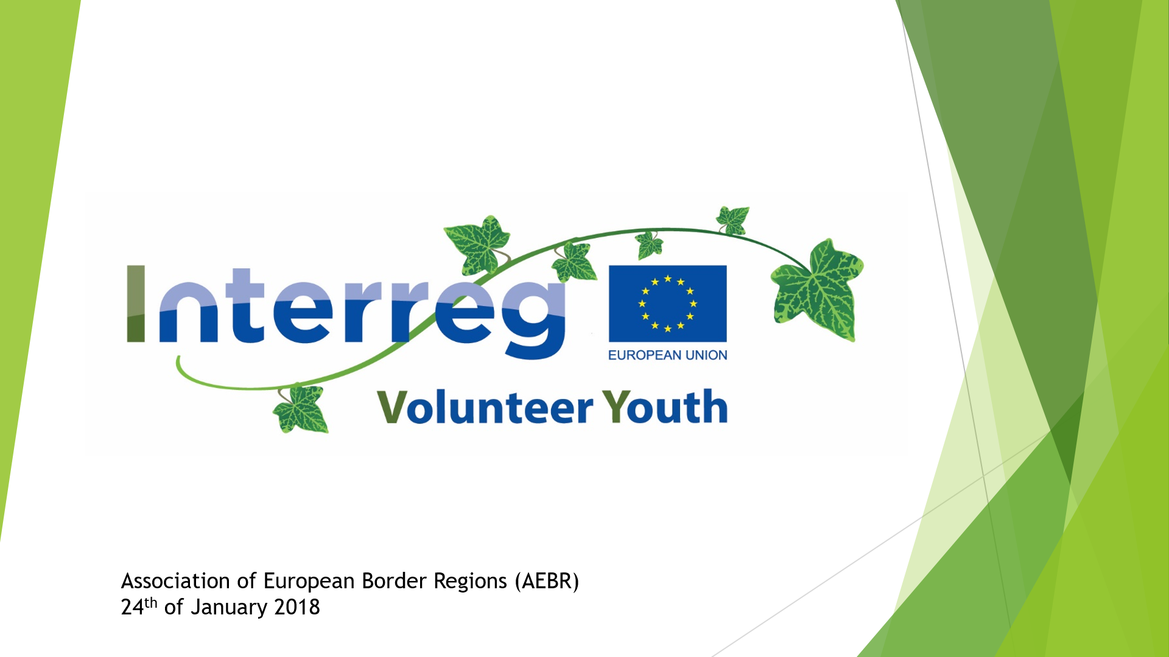
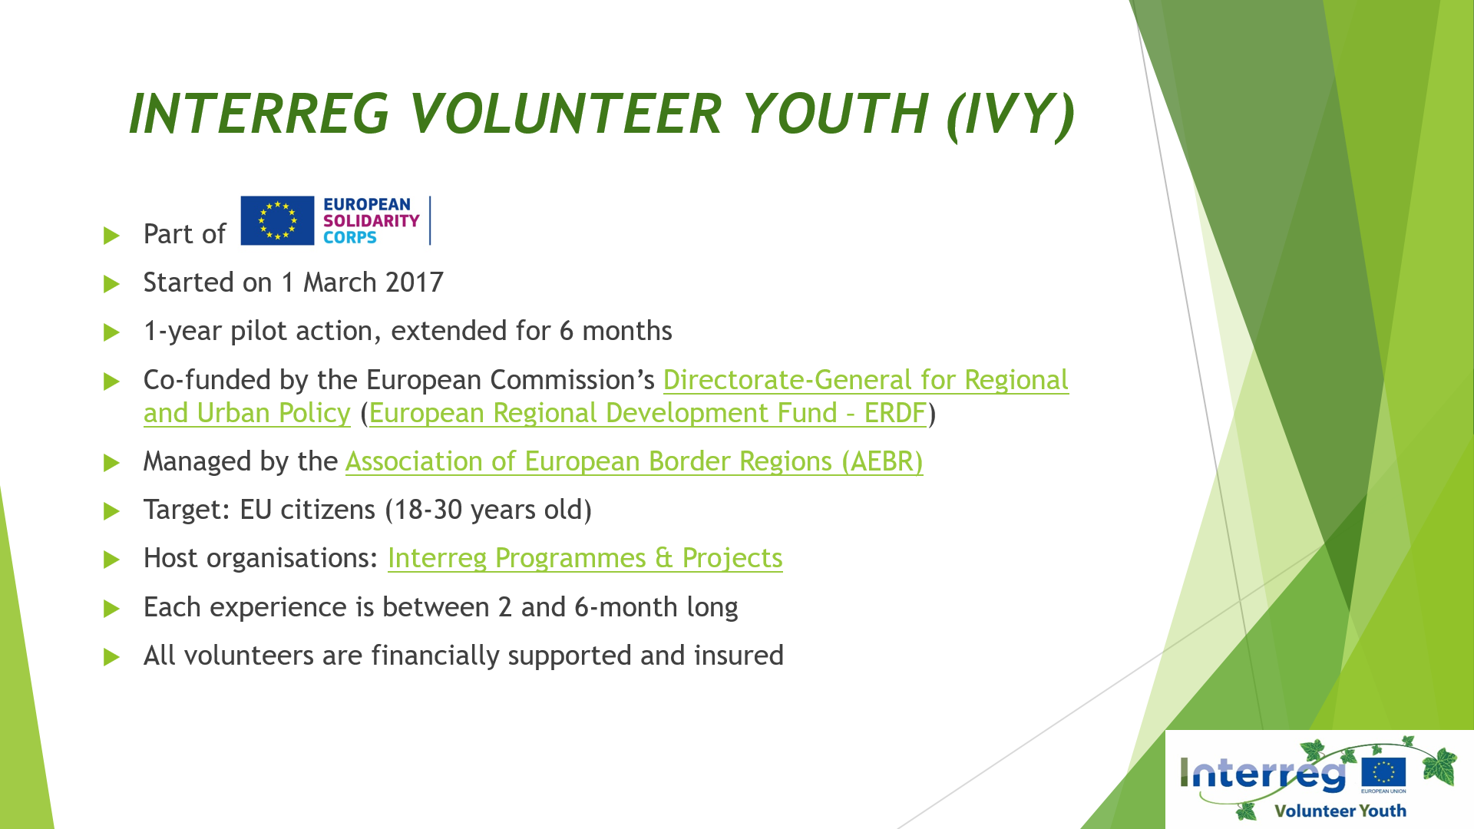

Slide 1 – Logos Slide 2
"Interreg Volunteer Youth" is part of the initiative "European Solidarity Corps", which was launched by the European Commission in September 2016 in order to bring the value of solidarity back on top of the political agenda of the European Union by mobilizing and deploying young Europeans as volunteers in different EU programmes.
IVY started in March 2017 and it is a pilot initiative initially planned to last for one year. If it is successful, it will last longer.
When the European Commission launched the European Solidarity Corps, it made an open call to all of its policy departments, and the Directorate-General for Regional and Urban Policy (DG Regio) decided to participate with an own initiative. Solidarity is a core value of Regional Policy, so the idea to strengthen it at the local level through to the many structures that DG Regio is already managing on the European territory seemed to be a successful one. "Interreg Volunteer Youth" was thus put in place: Interreg programmes and projects can host young Europeans as volunteers.
DG Regio, in cooperation with the Association of European Border Regions (AEBR), has created IVY so to promote fruitful relationships based on the principle of solidarity across the EU. The relationships which spur through the volunteering experiences show solidarity across the European regions and among different generations. In order to achieve this goal, funding from the European Regional Development Fund (ERDF) have been dedicated to support the engagement of young Europeans in projects which aim to foster cooperation among European countries at the local level.
The Association of European Border Regions (AEBR) manages IVY and arranges its development by bringing the actors involved together: the volunteers and the hosting organisations.

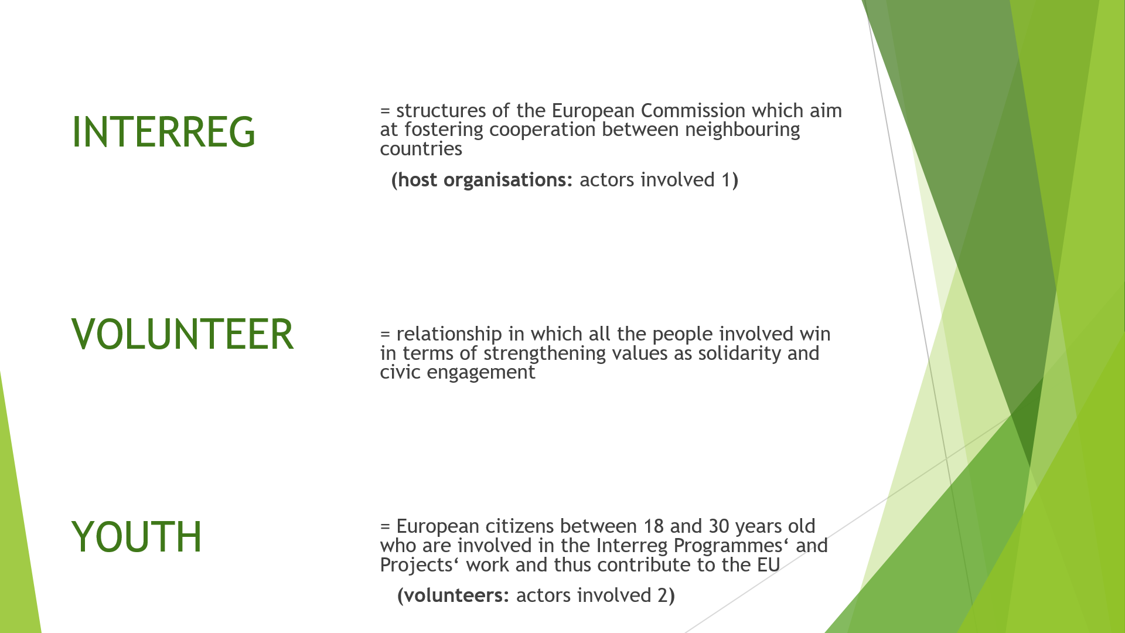
Slide 3
Interreg is a European Commission instrument to fund initiatives aimed at fostering cooperation between neighbouring countries. Thanks to Interreg, institutions and organizations —beneficiaries of the “Interreg Programmes”— at local and regional level everywhere across the EU, receive EU Structural and Investment Funds to implement projects in their area in order to support cooperation with their peers in their neighbouring country or countries.
The aim of IVY is to give young people the possibility to participate in these initiatives which truly create a more united and coherent EU and, at the same time, to help these programmes and projects to perform better and gain support thanks to the commitment of the volunteer. IVY wants to involve young Europeans in the work of organisations which are at the core of European integration. The objective is to bring organisations making EU in peripheral areas and the young generation of Europeans together, so to strengthen the solidarity dimension across the continent and make it more inclusive toward young people. And, finally, to make programmes and projects more visible thanks to the volunteers’ support to communicate them further and thus help these projects become more visible and better known to the local population.
IVY is thus present all over the EU —covering every border with volunteers who can help disseminate cooperation activities happening in the area—.
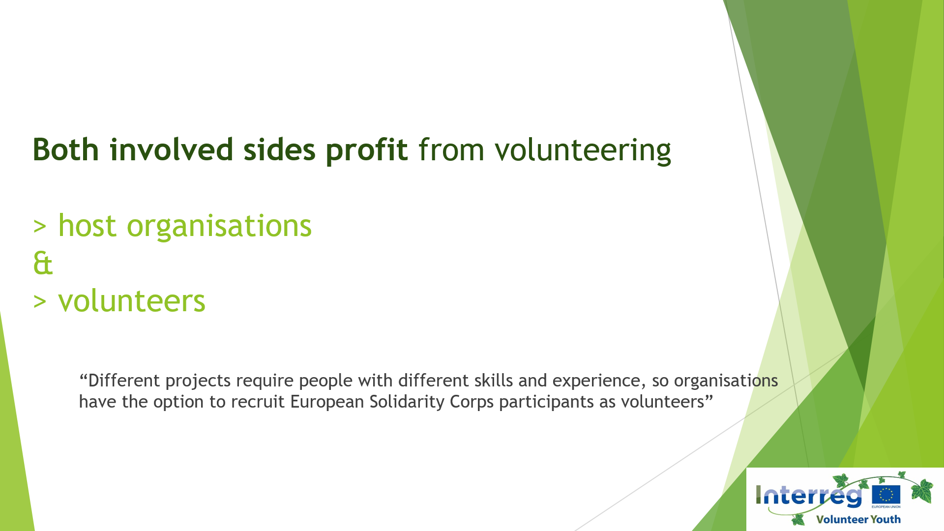
Slide 4
We understand volunteering as a relationship in which all parties involved profit from the experience:
- volunteers bring an added value to host organizations by bringing specific skills and experiences which can help host organizations better reach their goal;
- volunteers gain an empowering experience through giving their time and skills to others, but also through the learning experience. Volunteers also win political and civic awareness thanks to their engagement, as well as professional skills.

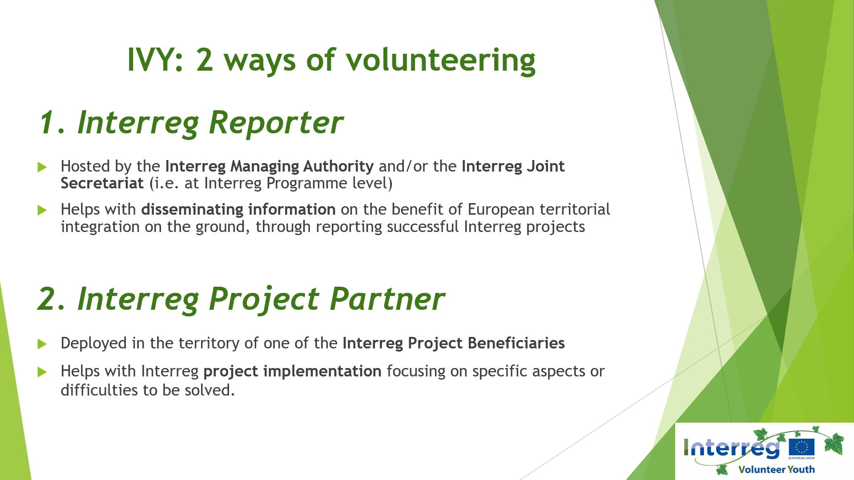
Slide 5
Interreg Reporters help in disseminating information for the benefit of European territorial integration on the ground, through reporting successful Interreg projects.
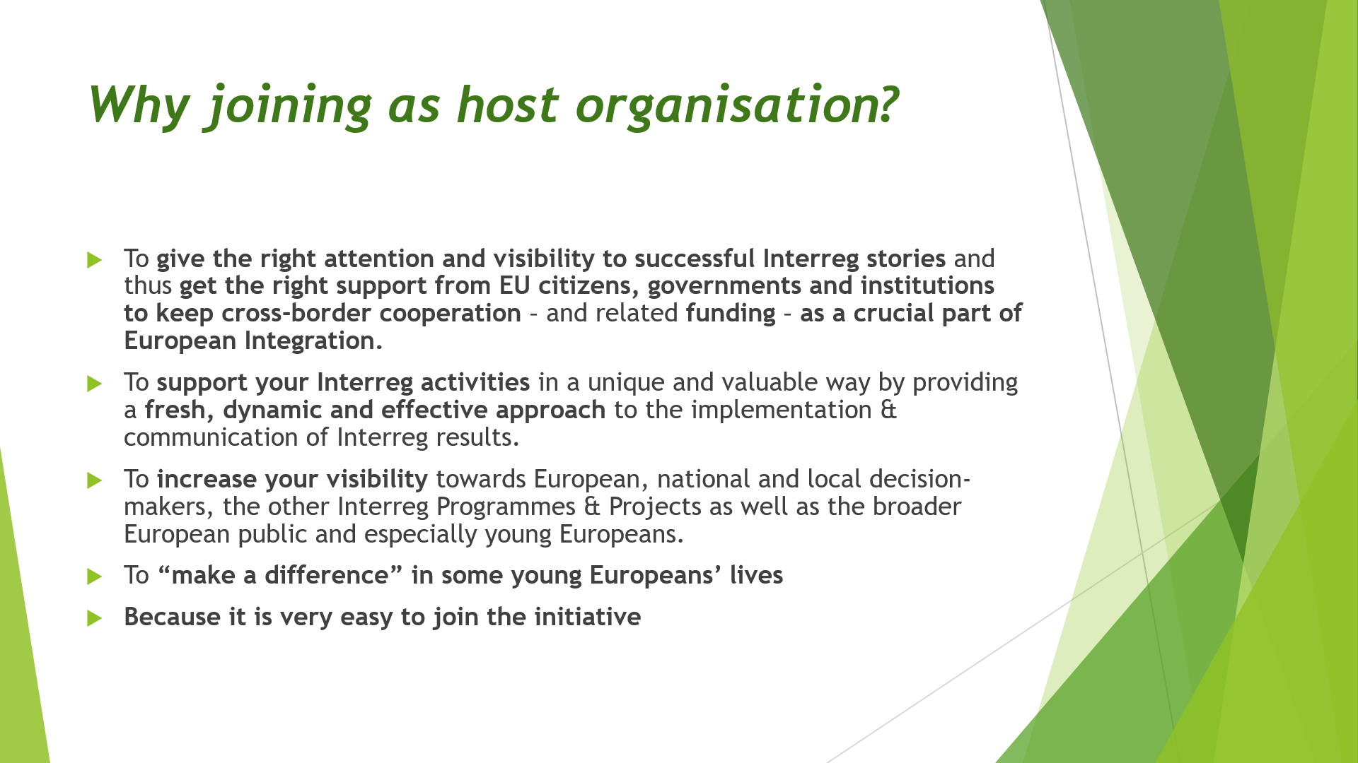
Slide 6
Added value of hosting a volunteer.

They are hosted by Managing Authorities & Joint Secretariats, the institutions which mediate between the European Commission and the beneficiaries of the Interreg funding (the projects).
Interreg Project Partners help with project implementation focusing on specific aspects or difficulties to be solved – they are hosted by the beneficiaries of Interreg funding, agencies, organisations, NGOs putting the projects in place at local level (Project Leaders and Project Partners).

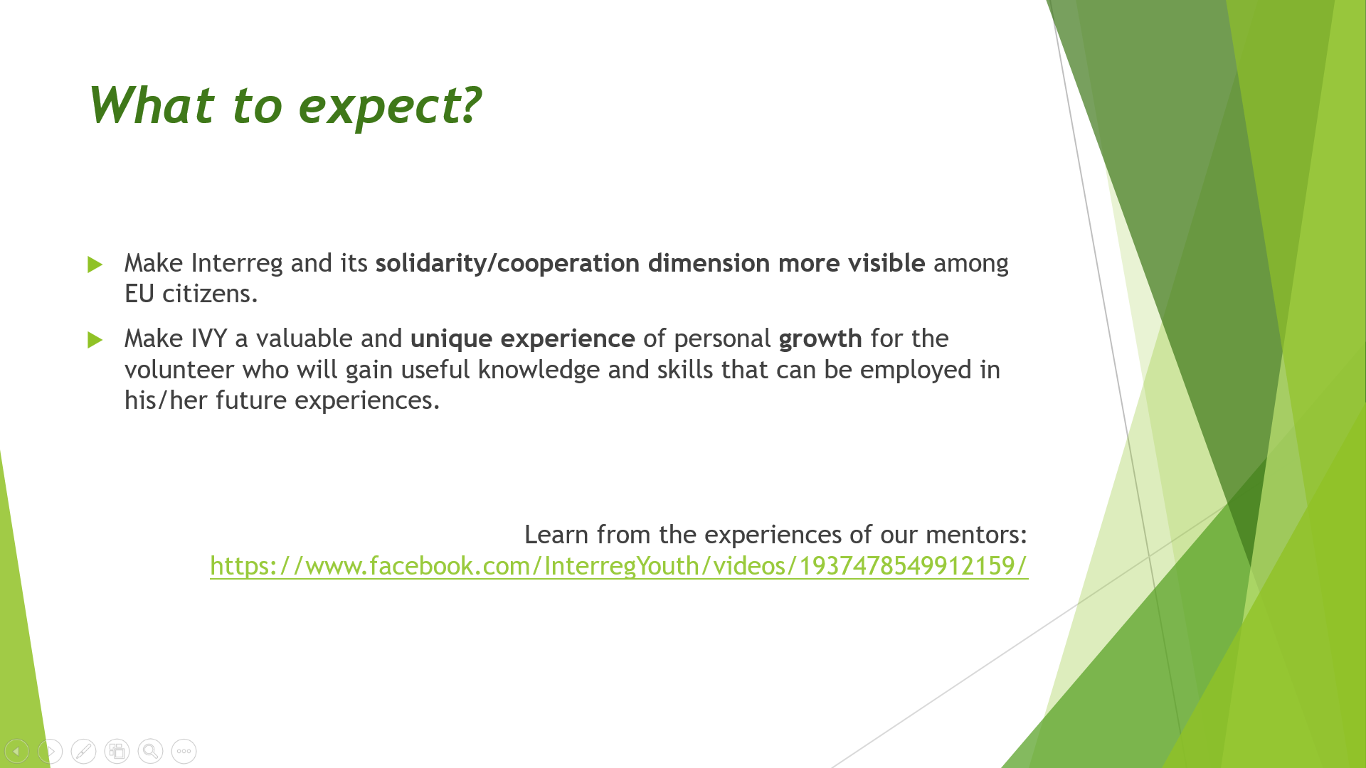
Slide 7
What to expect about hosting a volunteer.
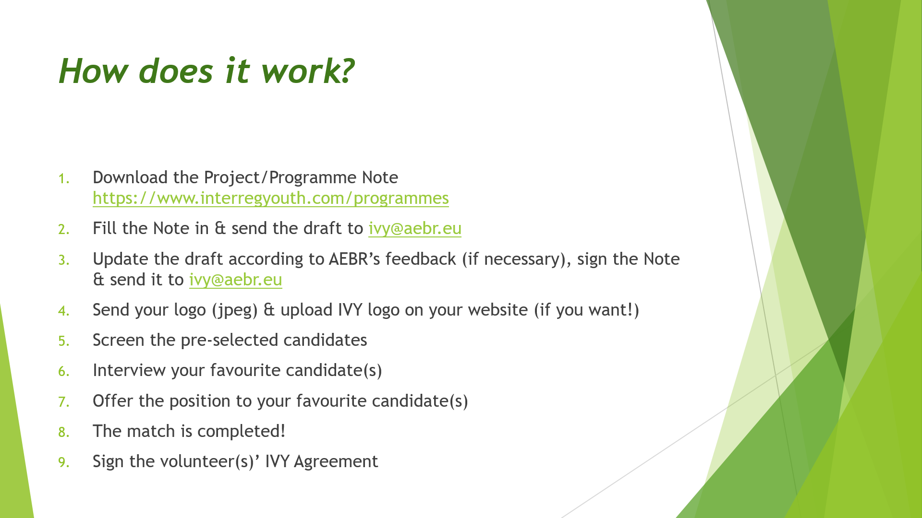
Slide 8
How the procedure to host a volunteer is.

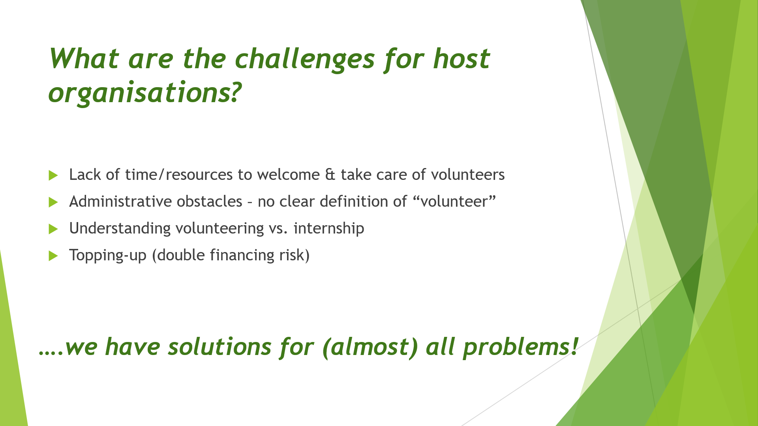
Slide 9
Which challenges might rise for host organisations and how AEBR solves them.
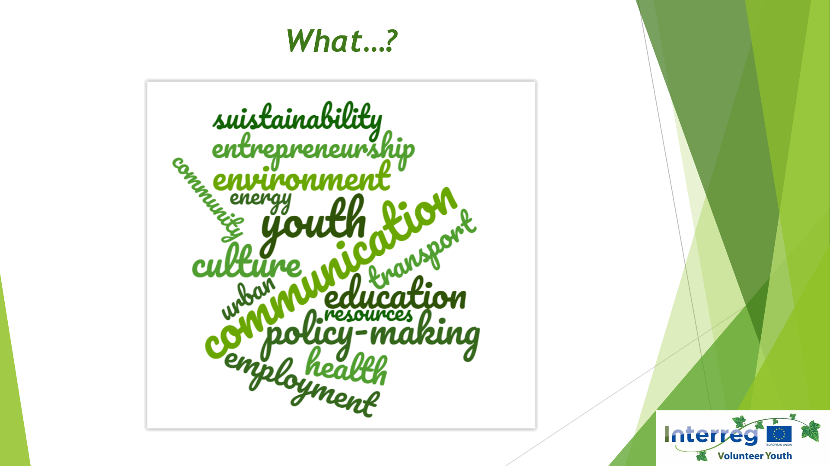
Slide 10
Interreg projects are implemented in many different fields: IVY volunteers are committed to various missions, from making communication on EU matters better understandable to a broaden public to helping in the project management by creating more efficient networks between partners involved in Interreg projects, helping with internal and external communication tasks, etc.

IVYs also supports projects which focus on environmental issues and natural protection, or which strengthen research opportunities on business possibilities in remote areas; some IVY volunteers assist in the creation of projects which bring together pupils and teenagers from neighbouring countries to make sure they receive the same opportunities, while other IVYs help raise awareness and improve research on health illnesses. Tackling unemployment and fostering entrepreneurship are the aims of other Interreg projects, as well as bringing artist from bordering countries together so that they can share their knowledge and expertise.

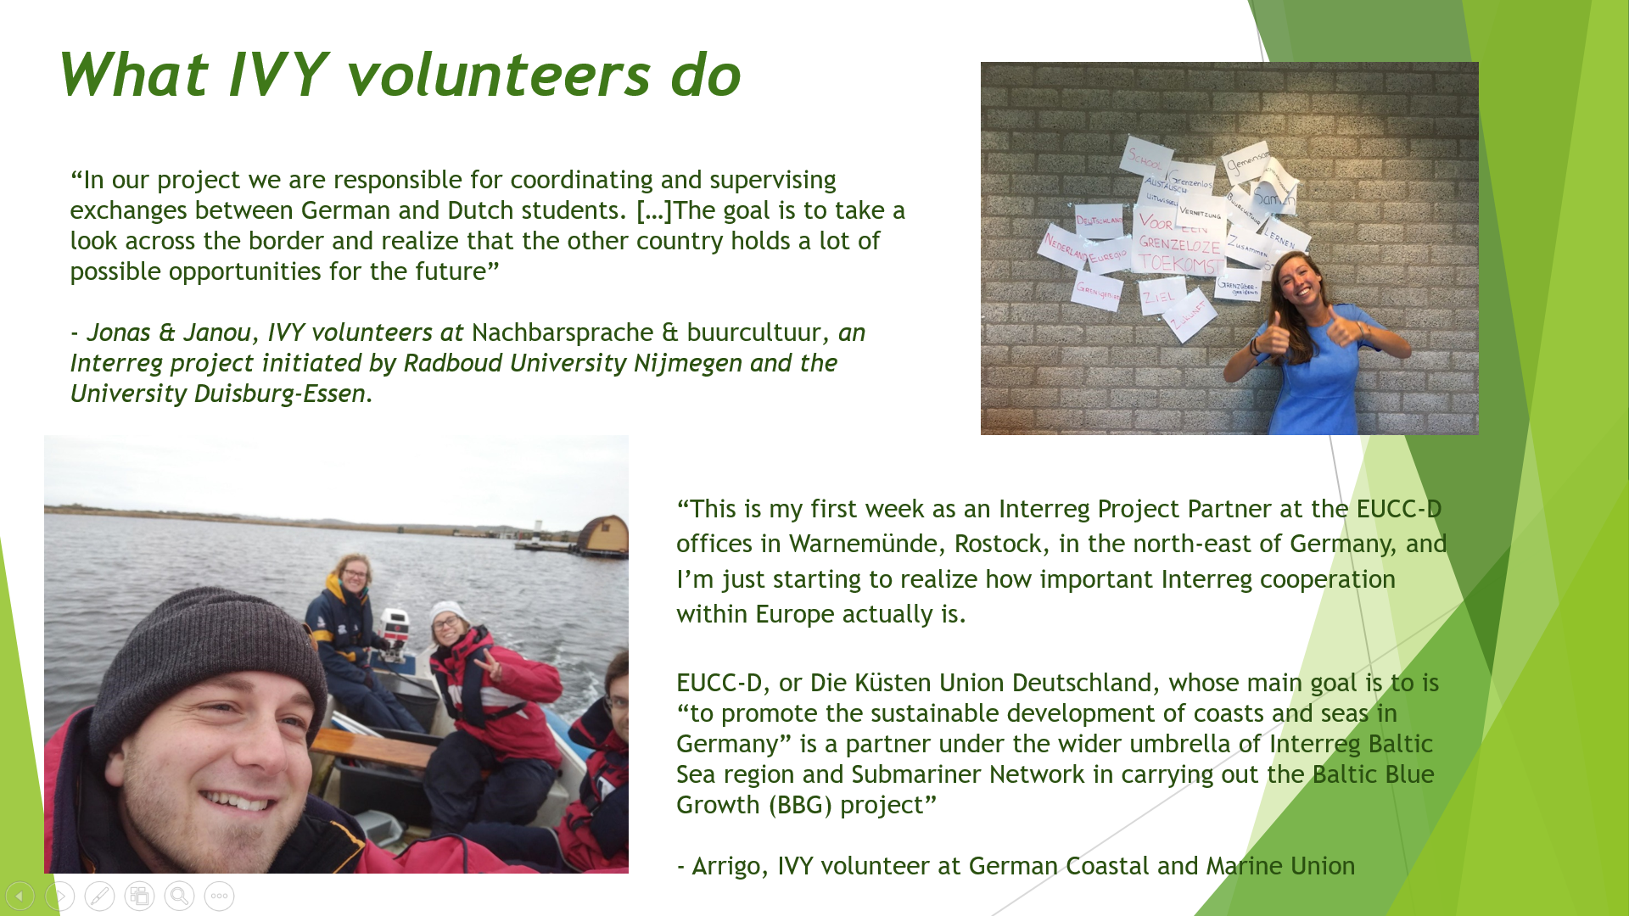
Slide 11
Some examples of what IVY volunteers do.

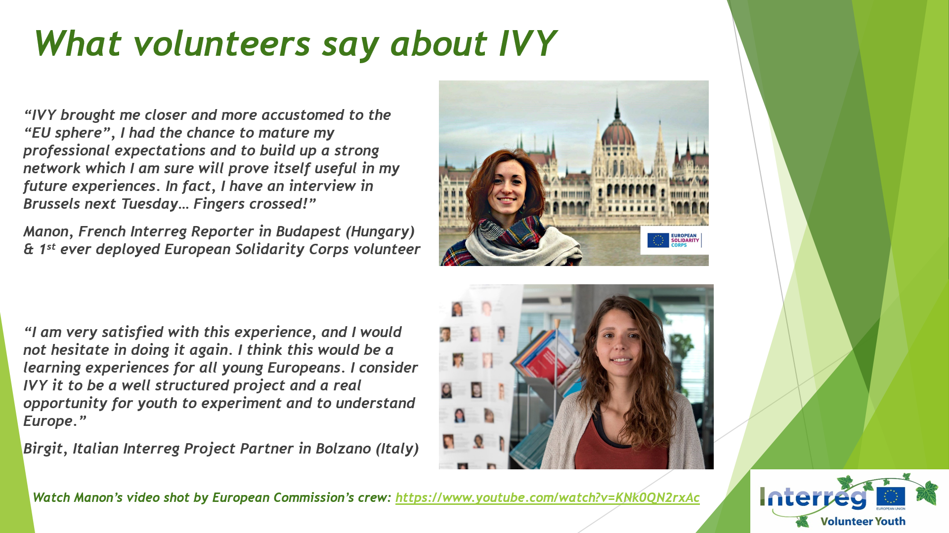
Slide 12
Some examples of what IVY volunteers learn during their experiences as Interreg Reporters or Interreg Project Partners.

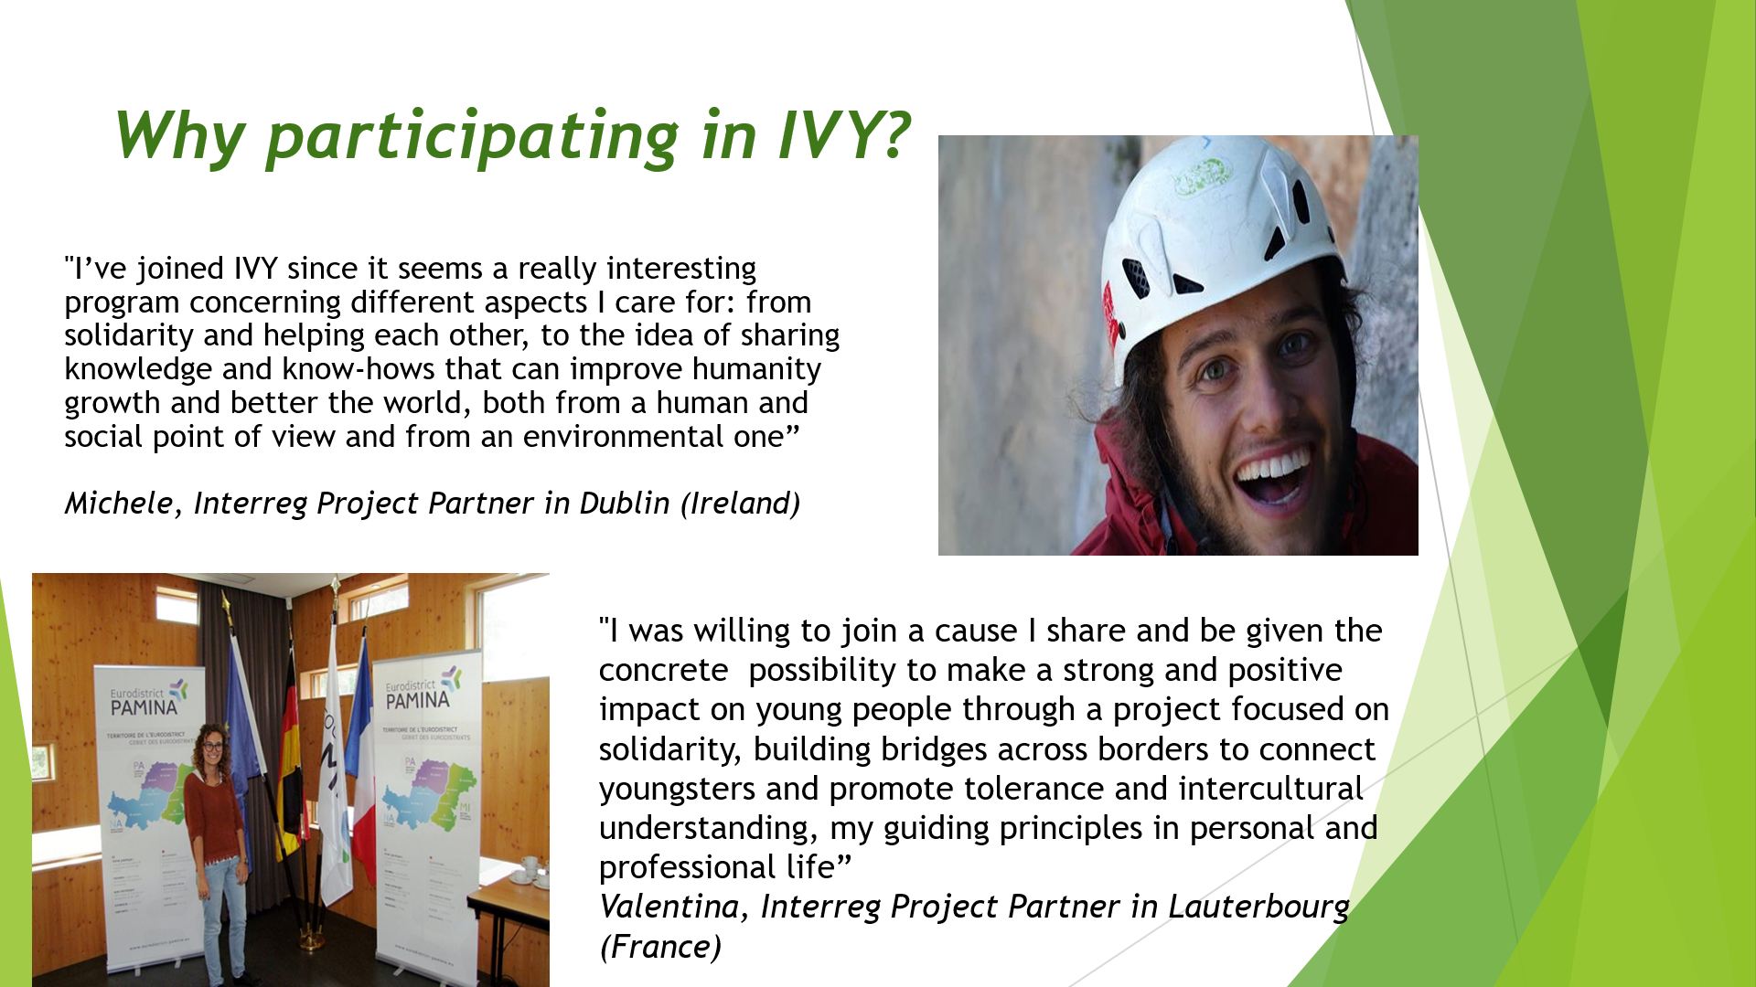
Slide 13
Some examples of why young people have decided to participate in the European Solidarity Corps and commit to help projects that bring people across Europe together.
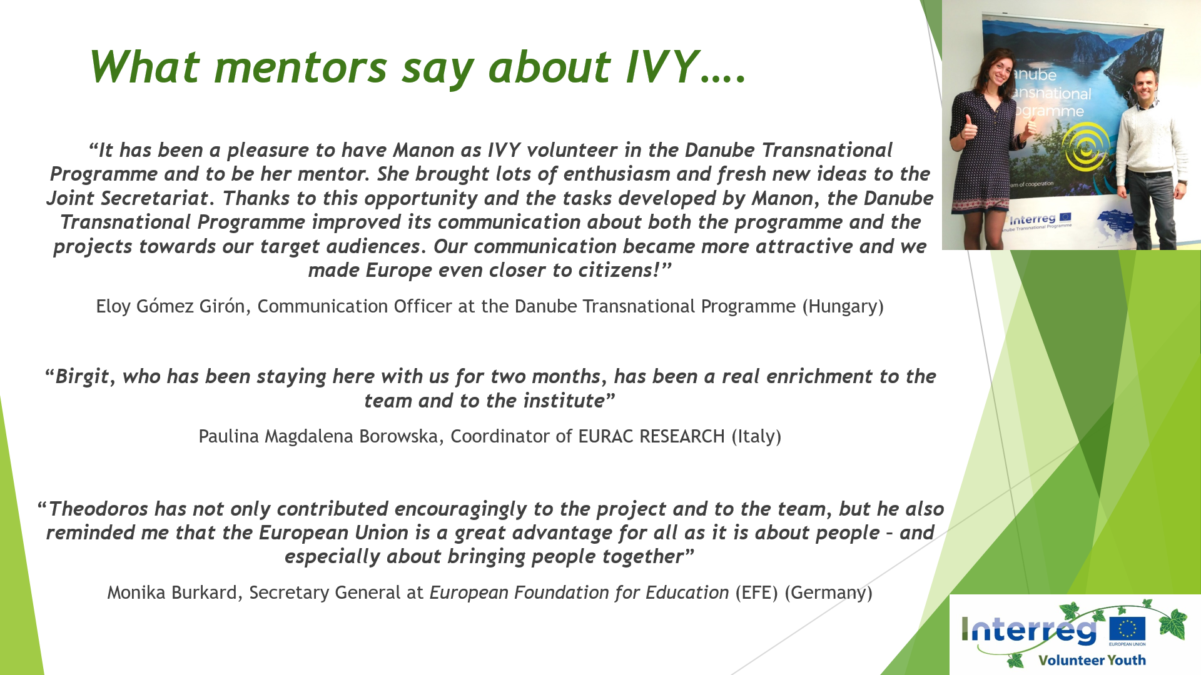
Slide 14
Some examples of experiences from the point of view of the host organisations.

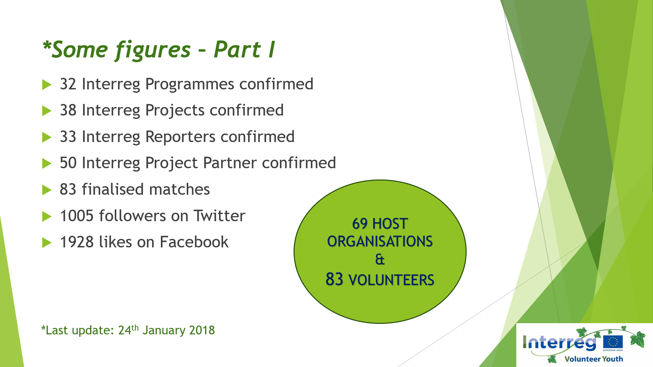
Slide 15
Some figures: what we have achieved up to now: 78 volunteers deployed all over Europe.
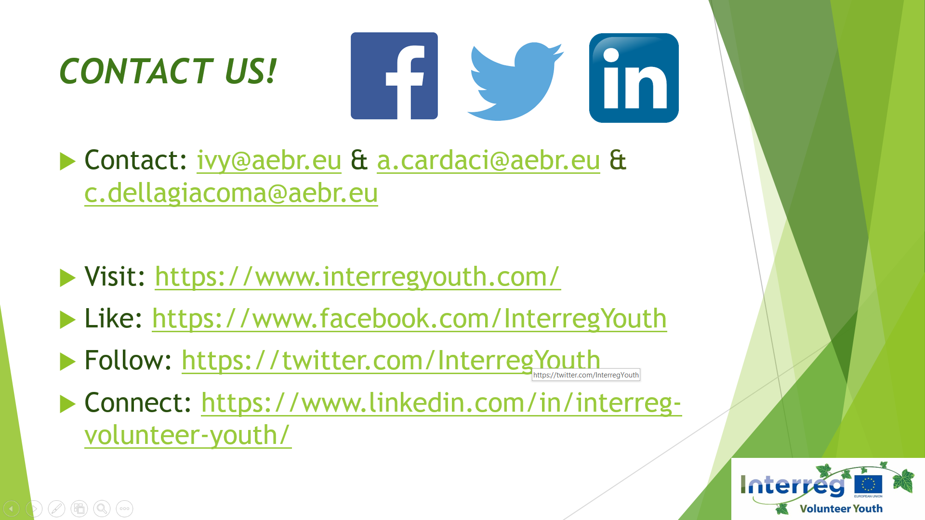
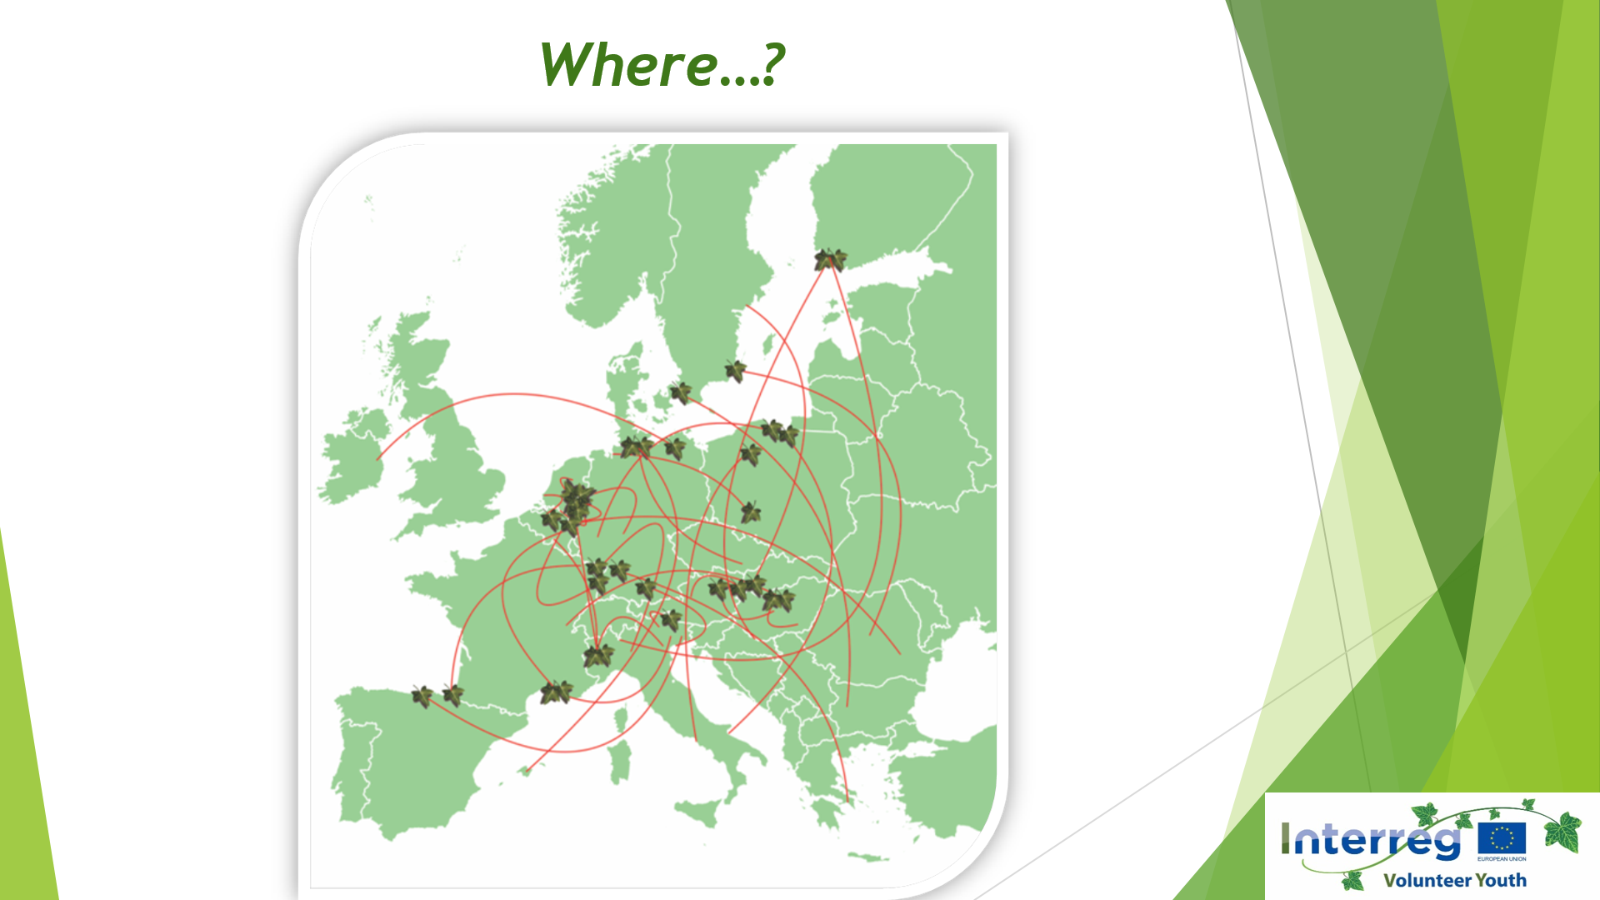
Slide 16
Where are deployed our volunteers and where are they from?
Currently confirmed host organisations are based in 19 different European countries: IVY volunteers are deployed in Austria, Belgium, Czech Republic, Denmark, Estonia, Finland, France, Germany, Greece, Hungary, Ireland, Italy, Lithuania, Netherlands, Poland, Slovakia, Slovenia, Spain and Sweden.
The volunteers come from all over Europe: from Belgium, Bulgaria, Croatia, Czech Republic, France Germany, Greece, Hungary, Ireland, Italy, Lithuania, Netherlands, Portugal, Romania, Spain and from Sweden.

IVYs deployed in: AT, BE, CZ, DK, EE, FI, FR, DE, GR HU, IE, IT, LT, NL, PL, SK, SI, ES, SE (19)
Missing: BG, CY, HR, LU, LV, MT, RO, PT, UK (+ CH + NO +AD + LI)
Volunteers from: BE, BG, HR, CZ, FR, DE, GR, HU, IE, IT, LT, NL, PT, RO, ES, SE
Yet missing: AT, BG, CY, DK, EE, FI, LU, LV, MT, PL, SI, UK

